# Football Statistics App “SRS”

## 1 Source of information

The main source of information is [Football Data API](http://api.football-data.org/documentation). We will need the following feeds:

1. Competitions
2. Teams
3. LeagueTable
4. Team Fixtures
5. Fixture
6. Single Team
7. Players

It’s free RESTful API which provides JSON data.

To handle API requests we will need to build a simple server that would be responsible for:

* Creating a request: formatting the URL and parameters
* Handling the response, possibly performing some data mappings

## 2 Pages

### 2.1 League table page.

League table page is the home page. Its mockup is presented on pic. 1:

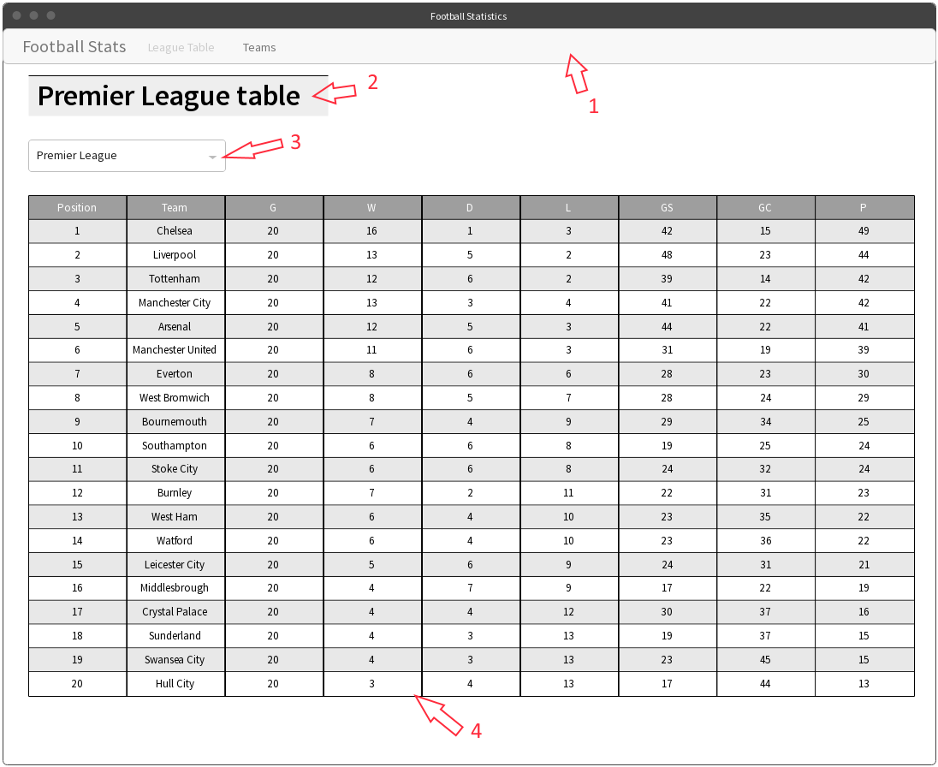

Pic. 1. League table page mockup

*Figure 1* is navigation bar. It’s common for all pages in the app. It contains following elements:

* Site logo: Football Stats.
* Navigation menu with two independent pages. When current page is one of the two, the corresponding menu item is disabled.

*Figure 2* is page header. It’s present on every page. Styling may vary, as the picture is a mockup. It contains the name of the league + “table”, and is dynamically updated when another league is selected.

*Figure 3* is League selector. We are interested in the following leagues (keeping the provided order is preferred):

1. English Premier League
2. German 1. Bundesliga
3. Spanish Primera
4. Italian Serie A
5. French League 1

When an item is selected, the table is updated to show the League table of the selected league. By default (on page load) the first item is selected, and therefore the league table for it is pre-loaded.

League Table is a table with the following columns:

1. League Position
2. Team
3. Games
4. Wins
5. Draws
6. Losses
7. Goals scored
8. Goals conceded
9. Points

All columns except for Team are integer values. Team column represents Club full name. Club name is clickable and leads to the 2.3 Team page.

### 2.2 Teams page

Teams page is a listing page for all the teams of a league. Its mockup is presented on pic. 2:

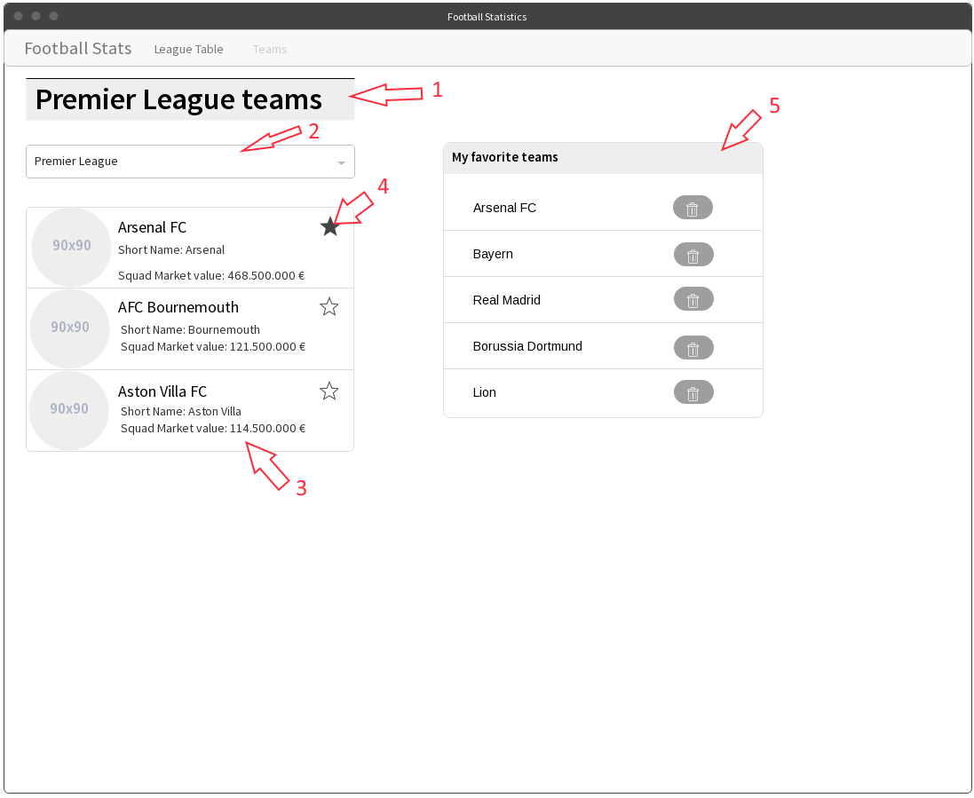

Pic. 2. Teams page mockup

It has the same navigation bar. “Teams” item should be disabled as it’s the current page.

*Figure 1* is the page header. It’s dynamically updated when another league is selected in the League selector, Figure 2. By default (on page load) the first league of the list is selected.

*Figure 2* is the League selector. It contains the same leagues as defined in 2.1 League table page.

*Figure 3* is Teams list. It contains all the teams that are returned for the selected league without any paging. Every item represents a single team and contains the following elements:

1. Club logo image. Its URL is provided by the API.
2. Club’s full name. It should be bolded and of bigger font size.
3. Short name. It’s provided by the API and should be displayed below the full name.
4. Squad market value. An integer number, value is provided in Euros. Delimiter should be a comma (,) and decimal mark is a dot (.).

Every items is clickable. It leads to the 2.3 Team page.

*Figure 4* is “Add to favorite” button. If the club is not added to the favorites, the star is empty, otherwise it’s filled with some color.

*Figure 5* is “Favorite clubs” list. It lists all clubs that has been added to the favorites. Each Club title leads to its detailed page. Every item has a “delete” button that removes it from the favorites list.

### 2.3 Team page

Team page represents detailed information about the Club. Its mockup is presented on the pic. 3:

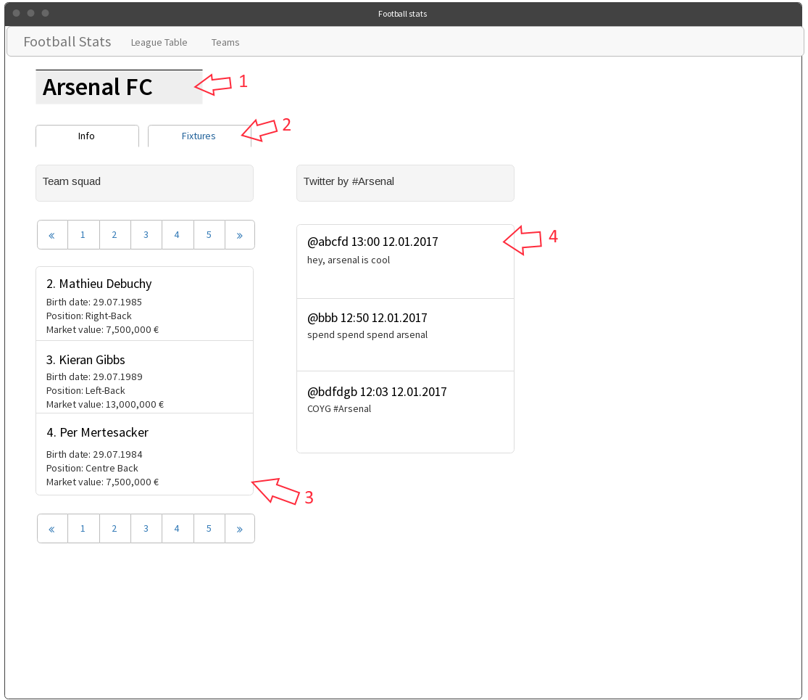

Pic. 3. Team page mockup 1.

*Figure 1* is page header. It shows the full name of the selected club.

*Figure 2* is tab control. It consists of two tabs: “Info” and “Fixtures”. All the content below is relevant for “Info” tab. Tab selection *must not* trigger full page reload, and current tab button should be disabled.

The “Info” tab consists of two layout columns: “Team squad” and “Twitter by…”.

*Figure 3* is the list of players available for the team. Every item represents one player. Every list item has a header, which should be bolded and of bigger font size. Item header has the following format: “<% squad number %>. <% player’s name %>“. All items should be ordered by squad number. Additional information about the player contains:

1. Birth date in the following format: DD.MM.YYYY.
2. Position – a string.
3. Market value – a price in the same format as described in 2.2 Teams page.

The list should be paged in case there are more than 20 items. If there are less than 20 items, paging controls should not be displayed. Otherwise, paging controls should be displayed both above and below the list.

*Figure 4* is the tweets list. It shows the most recent tweets that can be found using Twitter’s search with club’s name. It should display no more than 10 tweets. If there are no tweets found, there should be a well with “No tweets found for <% club name %>” text.

The “Fixtures” tab mockup is presented on pic. 4:

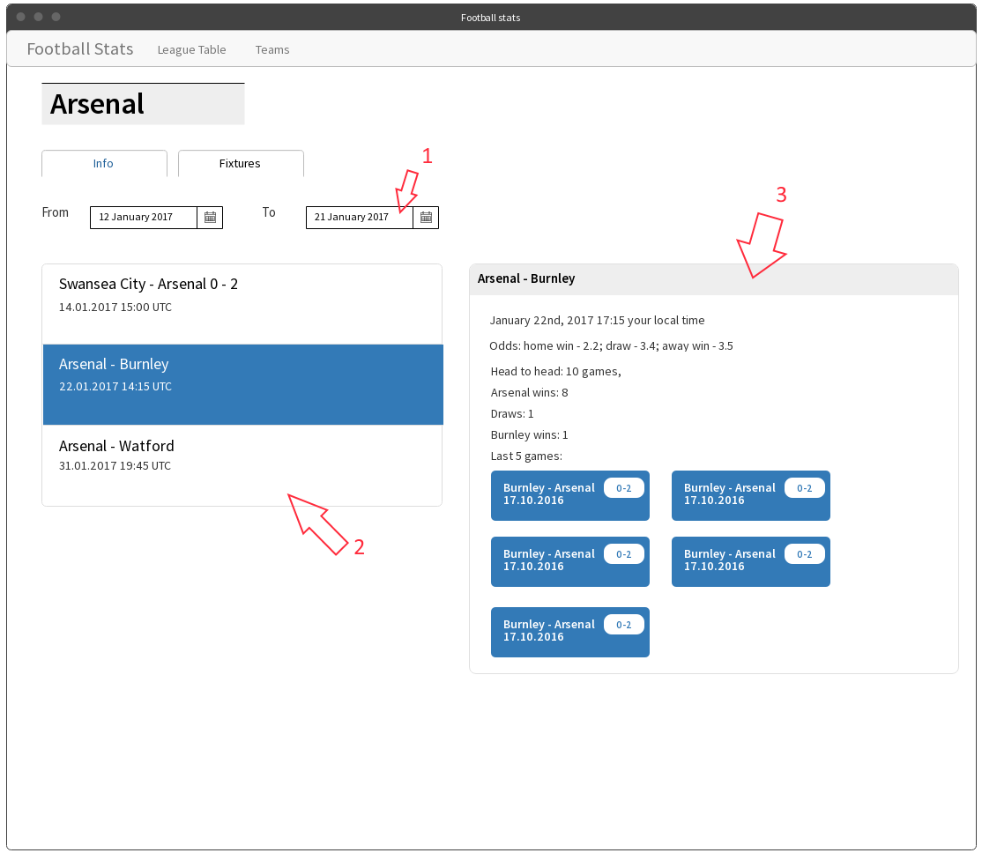

Pic. 4. Fixtures tab mockup.

*Figure 1* is a simple form that has 2 fields that represent “from” and “to” date limits for fixtures list. By default, “from” field is today and “to” fields is today + 2 weeks.

*Figure 2* is fixtures list. If the match has already taken place, the result is displayed alongside with the match title in the header. The header has the following format: <% home team short name %> - <% away team short name %> <home team score %> - <% away team score %>. Additional information is the date and time (in UTC) of the fixture. Optionally, the time may be converted to the current user’s time zone.

The list supports selection. The selected item should have a highlighted background. When an item is selected, fixture details appears on the right.

*Figure 3* is fixture details. It appears only if a fixture is selected in the fixtures list. Fixture details is a panel. Its header has the same format as fixtures list item header. The information in the panel includes:

1. Date and time in the following format: MMMM Do, YYYY HH:mm zz. Time may optionally be converted to user’s local time zone.
2. Odds if available. Odd is floating point number, one digit in the fractional part.
3. Head to head section. Head to head describes last 10 games (max) and provides number of each possible result: current home team win, draw, current away team win.
4. Last games section. We need to retrieve and show no more than last 5 games. Each game is a separate badge. The badge contains home and away team names, the final score and the date in the following format: DD.MM.YYYY. The badges should be inline and wrap.

## 3 General requirements

1. Use [Knockout JS](http://knockoutjs.com/) for interacting with the view. It has an [excellent tutorial](http://learn.knockoutjs.com/).
2. Use [Require.js](http://requirejs.org/) for module loading. Stick to CommonJS syntax.
3. Create a single-page application. Provide routing (preferably your own) for it.
4. Use ES2015+ syntax, but opt for classical syntax for classes and inheritance (with prototypes and Object.create) instead of ES2015 classes – they are just syntax sugar over constructor functions.
5. Use *XmlHttpRequest* for AJAX calls on the first phase, and *fetch API* on the second.
6. Provided pages are not designs and should not be implemented in pixel-perfect manner. Use any CSS library to style your pages. The main purpose of this task is to learn JS, not CSS.
7. Use [BEM](https://ru.bem.info/) methodology to create reusable and component-oriented CSS.
8. Use **local storage** to save user’s favorite teams.
9. Pay attention to keeping code clean and sticking to following principles: separation of concerns, single responsibility, KISS, YAGNI. The main goal of this exercise is to develop your skills in app architecture and code structuring.
10. Follow company [coding standards](https://wiki.itechart-group.com/display/codstandarts/Coding+Standard+JavaScript).
11. Do not overcomplicate your codebase so that you’ll need to build your front-end code on the first phase.

Mockups URL: <https://wireframepro.mockflow.com/view/itechart-football-training>.

## 4 Phases

### 4.1 Phase I

1. Implement mockups 2.1 League table page and 2.2 Teams page.
2. Use *XmlHttpRequest* and classical inheritance pattern.

### 4.2 Phase II

1. Implement 2.3 Team page.
2. Switch to *fetch API* for AJAX calls. It should as easy as possible to switch to another implementation.
3. Add front-end build process to create JS and CSS bundles.